|  |  |  |  |
| --- | --- | --- | --- |
| **Team number** | 6 | **Section** | 4 |
| **Team Members** | 1. Tanav Kudupudi 2. Saket Arora 3. Nick Tang | | |
| **Software Name** | LifeSmart | | |

## Introduction

* 1. **Objective**  
       
     This document presents the technical specifications of the web application. This document is intended for readers with a technical background that would like to understand the technical aspect of the application. The reader would need a software engineering background to understand the document.
  2. **References**   
       
     N/A
  3. **Acronyms, and abbreviations**

|  |  |
| --- | --- |
| N/A |  |
|  |  |
|  |  |

## Software overview

* 1. **Problem statement**  
       
     The need for a place where the average person can track their health and fitness information to reach their everyday health and lifestyle goals.
  2. **Scope**  
       
     The kind of users that would use this product are users that are health conscious and take good care of their health. In addition to that, users that need a way of motivation to stay healthy and workout.
  3. **Technological Requirements**  
       
     The technologies that we are going to use for this application are Java and JavaFX. The user would need a computer with a Windows, MacOS, or Linux which can run a web application.

## Detailed Design

* 1. **UML Class diagrams**

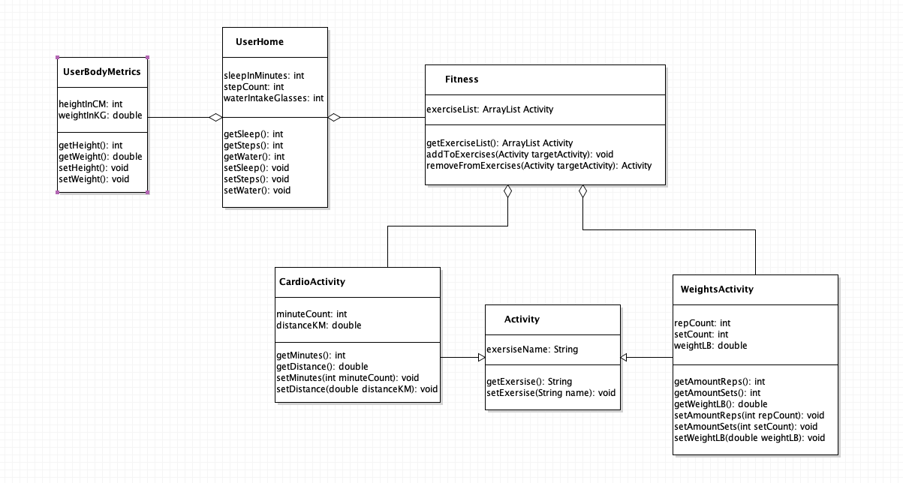

* 1. **UML Sequence and/or state diagrams**

1. User picks nutrition window
2. User picks Fitness window

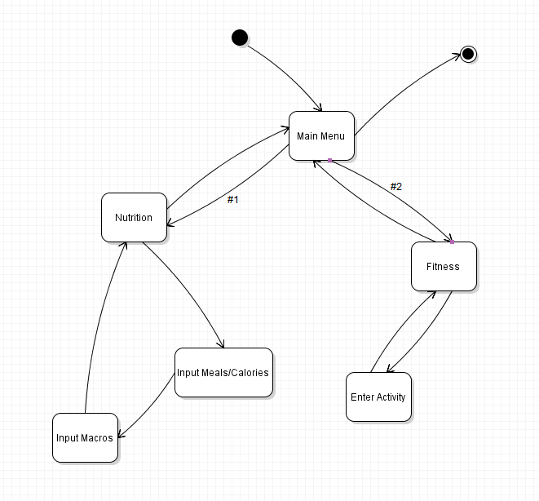

* 1. **User Interface**  
       
     Chart, pie chart

     Description automatically generated  
     Chart, pie chart

     Description automatically generated  
     Chart, pie chart

     Description automatically generated  
     Chart, pie chart

     Description automatically generated  
     Graphical user interface, text, application, chat or text message

     Description automatically generated  
     Graphical user interface, text, application

     Description automatically generated  
     Graphical user interface, text

     Description automatically generated  
     Graphical user interface, text, application, chat or text message

     Description automatically generated  
     Graphical user interface, application

     Description automatically generated